Unit 1 Lesson 1
The Unit Circle

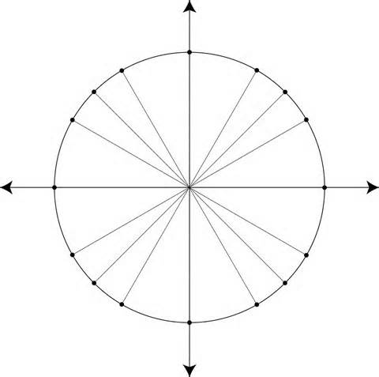
- Duplicate the circle on graph paper. Make the radius of your circle 10 squares long.
- Fold in the angle bisectors of the right angles formed at the origin. What angles result from these folds?
- Use a protractor to mark angles at all multiples of 30º .
- Which of the angles have reference angles of 30º?
- Which of the angles have reference angles of 60º?

