More Relationships in the Unit Circle
Day 3

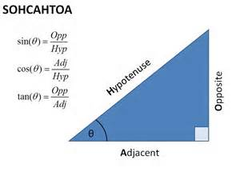

NEW!!!!
Reciprocals of sine, cosine, and tangent

Secant (sec) is reciprocal of cosine
Cosecant (csc) is reciprocal of sine
Cotangent (cot) is reciprocal of tangent

Ratios for reciprocals

Sec (x) = Hyp/ADJ
Csc (x) = Hyp/Opp
Cot (x) = Adj/Opp

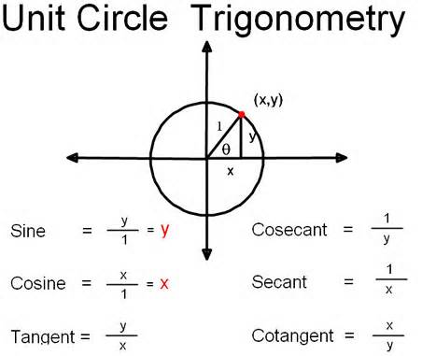
How is this related to the unit circle?

